Medical education resources statistics

Medical Education/For Educators library guide
Summary: From March – July 2017, there were 828 hits on this guide (no individual guide stats were available prior to March 2017)
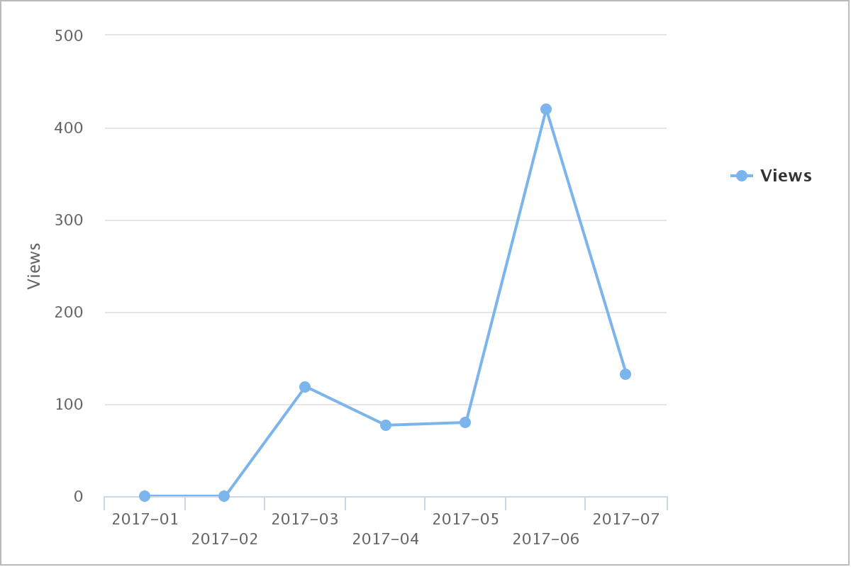

E-Journals
Summary: Medical Education and Medical Teacher are the most popular medical education journal titles in the collection. BJA Education is a very popular journal with trainees.
Title | Year | Total
Academic Medicine | YTD 2017 | 66
 | 2016 | 98
Title | Year | Total
BJA Education | YTD 2017 | 16188
 | 2016 | 16448
Title | Year | Total
The Clinical Teacher | YTD 2017 | 6
 | 2016 | 170
Title | Year | Total
Journal of Continuing Education in the Health Professions | YTD 2017 | 0
 | 2016 | 6
Title | Year | Total
Journal of Graduate Medical Education | YTD 2017 | 30
Title | Year | Total
Journal of Interprofessional Education & Practice | YTD 2017 | 2
Title | Year | Total
Journal of Surgical Education | YTD 2017 | 4
 | 2016 | 3
Title |  | Total
Medical Education | YTD 2017 | 117
Medical Education | 2016 | 209
Title |  | Tot
Medical Teacher | YTD 2017 | 276
Medical Teacher | 2016 | 693

E-Books
Summary: There are very few medical education e-books available through the ANZCA Library so consideration of the e-book version of popular print titles will be undertaken as part of the 2018 budget process.
Title | Year | Total
Making Sense of Clinical Teaching | YTD 2017 | 31
 | 2016 | 101
Title | Year | Total
Making Sense of Critical Appraisal | 2017 | 28
 | 2016 | 162
Title | Year | Total
Medical Education for the Future | YTD 2017 | 0
 | 2016 | 18
Title | Year | Total
Teaching Professional Attitudes and Basic Clinical Skills to Medical Students | YTD 2017 | 0
 | 2016 | 61

